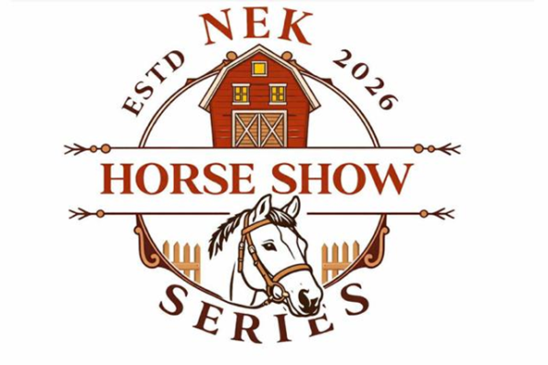

nekshowseries@gmail.com

NEK HORSE SHOW SERIES 2026 SPONSORSHIP FORM
SPONSORS NAME: ____________________________________________________

(Please print as it should appear in class list program and Facebook page)

Address: ________________________________________________________________

City/Town: ______________________________________________________________

Phone: ___ (_________) ____________________________________________________

Email: __________________________________________________________________

Class or Division Choice

- _______________________________________

- _______________________________________

- _______________________________________

Class Sponsorship $25 (per show) ~ Division Sponsorship $100(per show) ~ Series Sponsorship $250
If your choice(s) are not available NEK horse show committee reserves the rights to substitute a class or division if your choice(s) are already reserved.
Sponsorships must be received by May 25th, 2026, to be included in program.
Sponsorships received after this date will be announced at show and on Facebook page.
For more information about sponsorship packages visit our website www.nekhorseshow.com
Thank You!

Patron: $ ___________________________ Donor: ______________________________

Please return Sponsorship forms to:
NEK Horse Show Series
C/O Sonia Koehler
50 Lakeview Dr.
Newport, VT 05855

