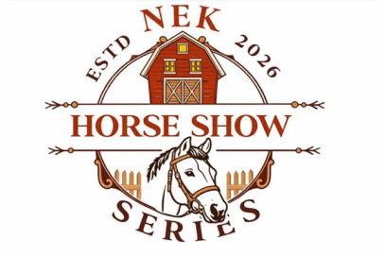
NEK Horse Show Series 2026

nekshowseries@gmail.com
Show starts at 9 a.m. Rain or Shine Classes may be combined or divided, pending number of entries.
Championship Classes in Bold text.
 Into Ride the Pattern 20 minutes Max Free to all

- Pee Wee Showmanship
- Green Horse/Adult W/T Showmanship
- Youth Exhibitor Showmanship
- Adult Showmanship
- $$$ Showmanship Championship $$$
- Miniature Horse Model
- 3 & under Halter Model
- English Type Model
- Color Breed Model
- Western Model
- $$$ Model Championship $$$ (6-9)
** 15 Minute Break **
- Lead-line Equitation
- Lead line Pleasure
- Youth Exhibitor Equitation
- Adult Equitation
- Youth Exhibitor Walk/Trot Equitation
- Adult W/T - Green Horse/Pony Equitation
- Pee Wee Equitation
- Pee Wee Exhibitor Pleasure- All Seats
- Miniature Horse Driving
- Miniature Horse Jumping
Approximate Lunch Break for 30 Minutes
- Western Pleasure Horse Open
- English Pleasure Horse Open
- Youth Exhibitor Walk/Trot Pleasure- All Seats
- Adult W/T- Green Horse/Pony Pleasure All Seats
- $$$ NEK CASH CLASS $$$ - Open
- Walk/Trot Discipline Rail
- Open Discipline Rail (Youth & Adult)
- Youth Exhibitor Pleasure - All Seats
- Adult Pleasure – All Seats
- $$$ NEK CASH CLASS $$$ – Walk/Trot
- Open Pattern Class
- Walk/Trot Pattern Class
- Versatility English
- Versatility Western
- $$$ English Pleasure Championship $$$ (Qualifying classes)
- $$$ Western Pleasure Championship $$$ (Qualifying class)
- $$$ Walk/Trot Pleasure Championship $$$ (Qualifying class)
- Trail Open (June Show Only)

- Trail In-Hand (June Show Only)

DAY END CHAMPIONSHIP CLASSES
Classes to qualify for day end Championships Need to compete Classes 7.
Mini, Lead Line & Pee Wee needs to compete in all classes

Leadline 12 &13

Pee Wee 1, 18, 19

Mini 2, 3, 4,5,6,20,21

Youth W/T 3, 5, 16, 24, 27, 31, 33, 38
Youth 3, 5, 14, 22, 23,26,28,29,32,34,35.36,37

Adult 4,5,15,22,23,26,28,30,32,34,35,36,37

Adult W/T Green Horse 2, 5,17,25,27,31,33,38

